**CO2 PROGRAMS**

**PROGRAM1**

n=int(input("enter a number"))

f=1

for i in range(1,n+1):

f=f*i

print("factorial of",n,'=',f)

OUTPUT

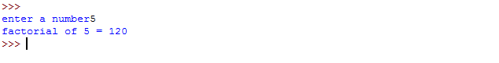

**PROGRAM2**

n=int(input("enter the limlt"))

a=0

b=1

sum=0

count=1

print("fibonacci series",end="")

while(count<=n):

print(sum,end=" ")

count+=1

a=b

b=sum

sum=a+b

OUTPUT

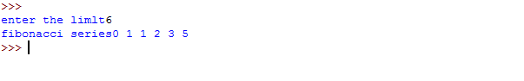

**PROGRAM3**

list1=[10,15,20,25,30]

total=sum(list1)

print("sum of list:",total)

OUTPUT

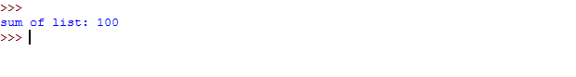

**PROGRAM4**

from math import sqrt as s

for i in range(1000,10000):

if s(i)==int(s(i)) and i%2==0:

print(i,end=" ")

OUTPUT

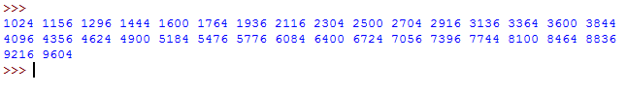

**PROGRAM5**

rows=int(input("enter a number of rows"))

for i in range(1,rows+1):

for j in range (1,i+1):

print(i*j,end='')

print()

OUTPUT

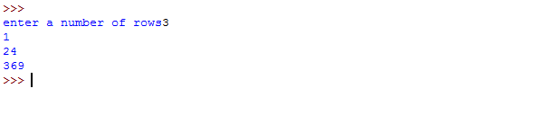

**PROGRAM6**

test_str=str(input("enter the string"))

freq={}

for i in test_str:

if i in freq:

freq[i]+=1

else:

freq[i]=1

print("count of all characters:"+str(freq))

OUTPUT

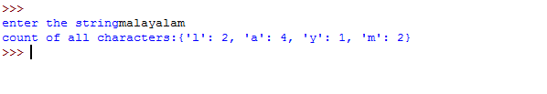

**PROGRAM7**

str=input("enter a string")

print("inputted string is ",str)

if(str.endswith("ing")):

str=str+'ly'

else:

str=str+'ing'

print("the formatted string is",str)

OUTPUT

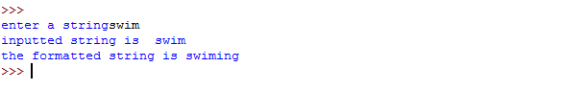

**PROGRAM8**

a=[]

n=int(input("enter the number of elements in list"))

for x in range(0,n):

element=input("enter element"+str(x+1))

a.append(element)

max1=len(a[0])

temp=a[0]

for i in a:

if(len(i)>max1):

max1=len(i)

temp=i

print("longest word",temp)

print("length of longest word:",max1)

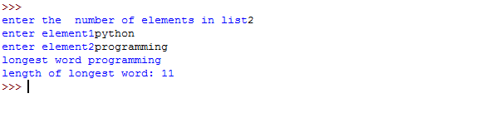

**PROGRAM9**

n=int(input("enter the limit"))

for i in range(n):

for j in range(i):

print('*',end="")

print('')

for i in range(n,0,-1):

for j in range(i):

print('*',end="")

print('')

OUTPUT

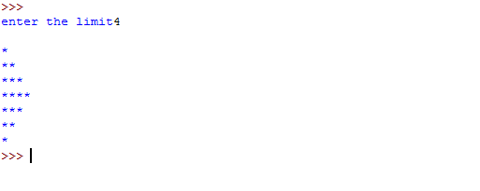

**PROGRAM10**

def factors(x):

print("the factors of",x,"are")

for i in range(1,x+1):

if x%i==0:

print(i)

n=int(input("enter a number:"))

factors(n)

OUTPUT

